User Guide
atos
holiday chat agent – Synoptic project
Jamie Butler
2021

Contents
User Guide 2
User Journey Design 2
Annotated Guide 2

User Guide

User Journey Design
- User enters message to Text Input Field and clicks the Send Button.
- Chatbot sends message through the MessageParser, parses the message using custom parse logic.
- Chatbot responses with appropriate message based on the keyword parsing logic.
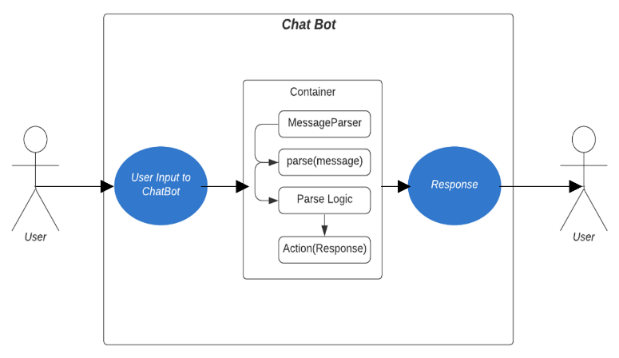
- User views message, then repeats the process until all user-queries are satisfied and the Chatbot window is closed.

Annotated Guide

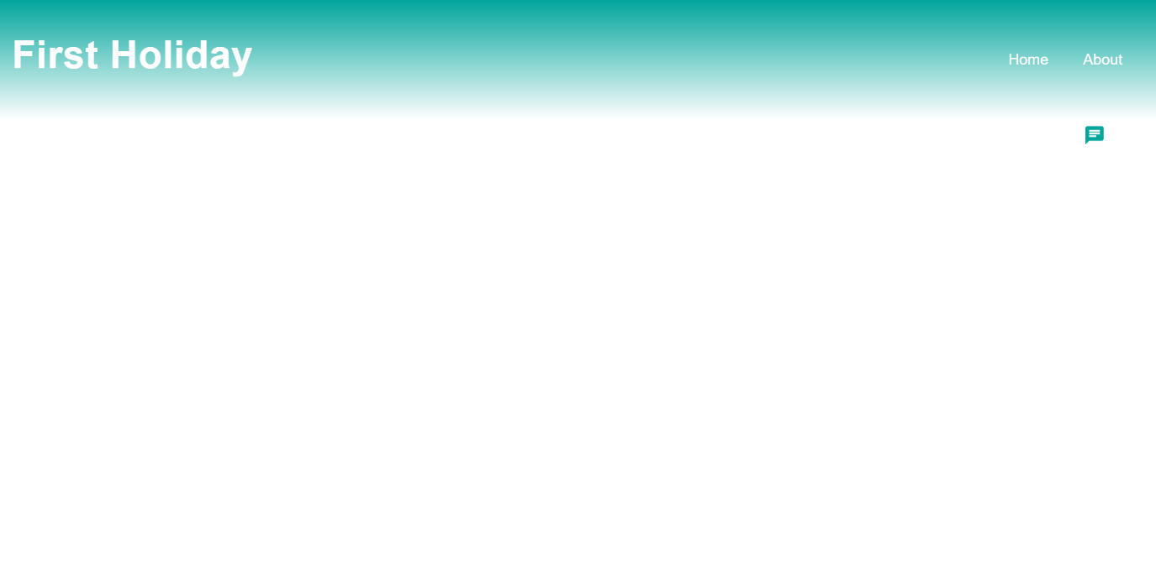
The user’s first step is to activate the Chat Agent using the Chat Agent Modal
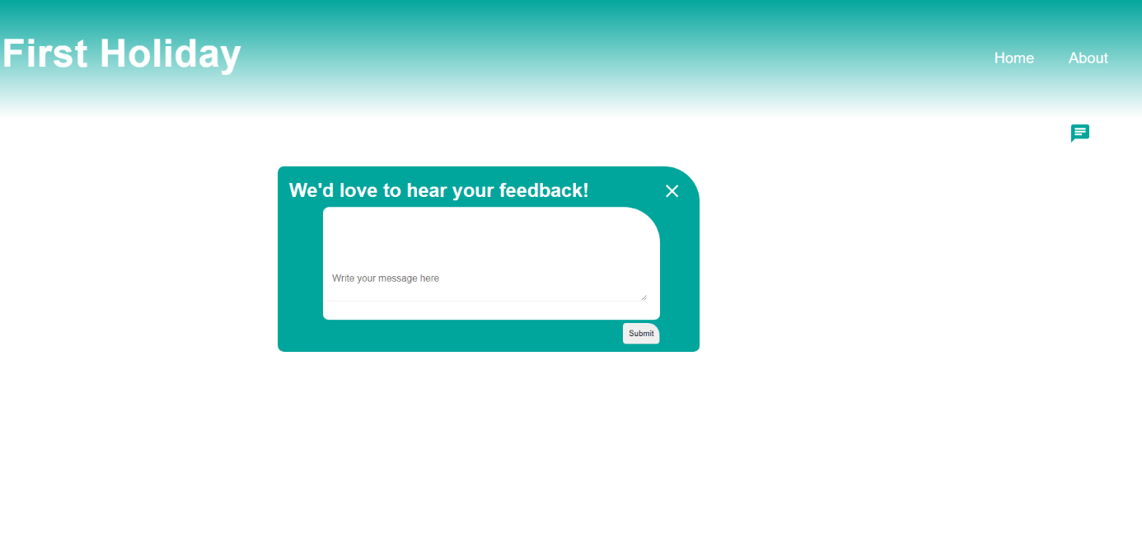
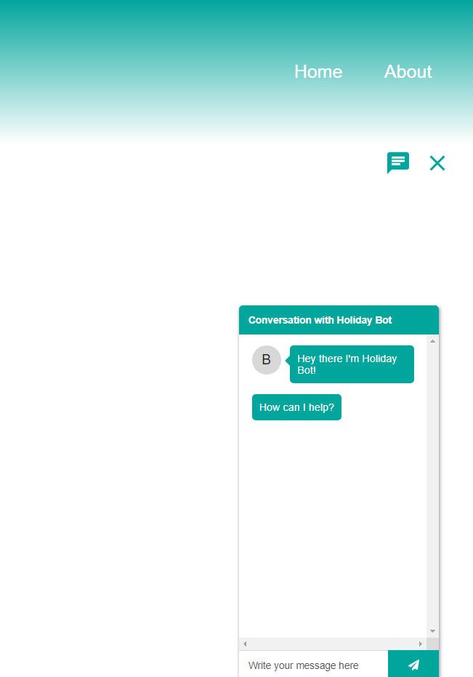
The feedback modal will appear in the centre of the screen, where users can give their feedback on the Chat Agent.
The user will then view the Chat Agent in the bottom right-hand corner of the webpage.
From here, the user may enter messages into the text field, press send and see their message render in the Chat Agent, along with the responses produced by the Parse Logic.
When the Chat Agent prompts the user with multiple options, the user can then type their chosen option, and the Chat Agent will continue to Parse until the user receives the recommendation for Holiday hotels.
When the user closes the Chat Agent for the first time, using the close button, the user will be prompted to provide User-Feedback in the text area. Submitting the feedback using the submit button, the feedback menu can then be closed with the close button in the top right.

